**Requirements Specification**

Group Name

Group Members (include studenID’s)

**Overview**

*This document is submitted in partial fulfillment of the Business Application Development module 2017 delivered by Manuel Tova-Izquierdo.*

Table of Contents

Product Overview 3

Use Case Design 3

GUI 3

Technical Specification 3

Gantt Chart 3

Deployment Strategy 3

# Product Overview

200 words describing the product. **[10% of Marks]**

# Use Case Design

Each group must create suitable Use Case diagrams to encapsulate the functionality required in their project. **[20% of Marks]**

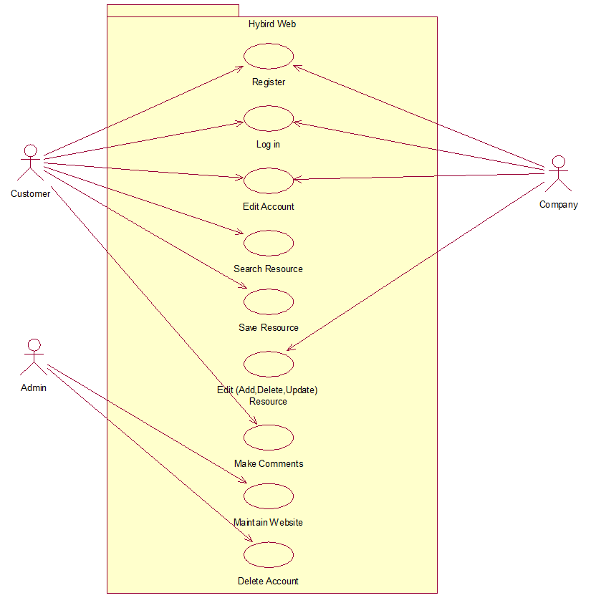

# Use Case Description

## **Use Case One:**

Customer Search Resources

**Scope:**

The scope of this use case is for customers search any resources relative to their needs including services and events.

**Description:**

This use case describes the process that how customers search for the resources that they required.

**Flow Description**

***Precondition:***

The system is idle and available.

***Activation:***

The use case starts when customers type in the search box or browsing the website.

***Main flow:***

1. Customers start to search the resource. [a1 From Navbar] [a2 From Search box]
2. List of links which relative to the search topic will showing on the pages, and customers can click the link to get more information.
3. The key words that customers used to search and also the links which are opened will be stored in the history after customer’s log in.
4. The searching resource can be saved by customers to their Favorite.

***Alternate flow:***

(A1 From Navbar)

1. Different categories of services or events will be listed under the navbar.
2. Customers choose the resources they required.
3. Continue in main flow point 2.

(A2 From Search box)

1. The link pages will not be showing up when customers type the wrong words.
2. The link pages will not be showing up when there are no relative resources.
3. Continue in main flow point 2.

***Exceptional flow:***

The links will not jump to the information pages when the website is being maintained by Admin or when there are too many users browse the website.

***Termination:***

Customer stop searching resources.

***Post condition:***

The system goes to a wait state

## **Use Case Two:**

Company Edit Resources

**Scope:**

The scope of this use case is for companies edit the information of the resources.

**Description:**

This use case describes the process that companies add, delete or update the information of the resources

**Flow Description**

***Precondition:***

The system is idle and available.

***Activation:***

The use case starts when companies edit resources in the manageable page.

***Main flow:***

1. Companies log in to the website (a1 Register).
2. Go to the manageable page and start edit the information of resource.
3. Save the changes for updating.

***Alternate flow:***

(A1 Register)

1. Companies who haven’t log in to the website cannot edit the information of resources.
2. Continue in main flow point 2.

***Exceptional flow:***

The editing will not be process when the web pages are being maintain.

***Termination:***

Companies stop editing the information and save all the changes.

***Post condition:***

The system goes to a wait state

# GUI

Each group must include mock-ups of the key pages or stages of the system. Explain how they are linked. Explain how you addressed requirements in the design. It is important that the mock-ups are in line with the functional requirements, e.g. one requirement is “user registration” then one of the screens listed in this section should show a registration page. **[20% of Marks]**

# Technical Specification

The requirements of the project should be mapped against suitable technologies. Each group is required to build their solution using Bootstrap, PHP and MySQL, however addition libraries and APIs should be identified in this section to demonstrate a technical understanding of how the group will complete the project. **[10% of Marks]**

# Gantt Chart

Each group must de-couple their project into manageable chunks and create a suitable Gantt Chart to illustrate the timeline for the project. **[30% of Marks]**

# Deployment Strategy

The group should describe how they are going to deploy their solution prior to the end of the module. **[10% of Marks]**